Middle East Area of Operations

Commemorative Dinner and Service

Saturday 17 October 2026

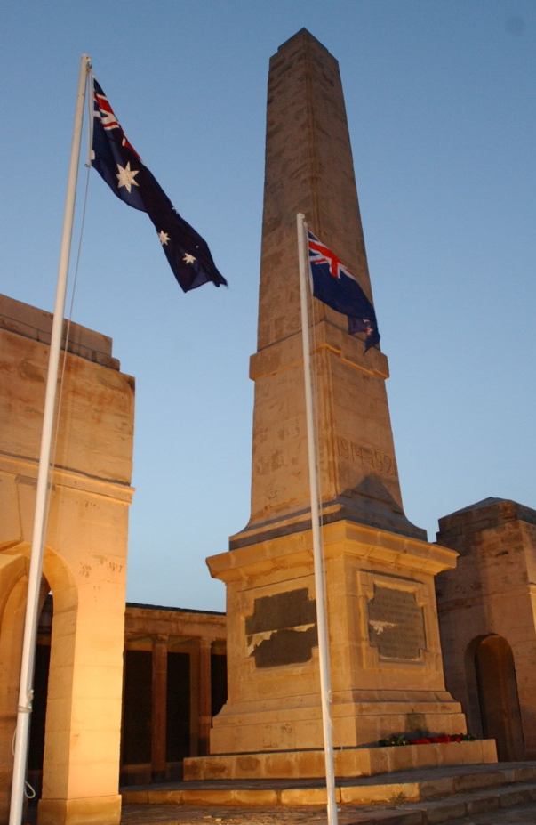

The Gracemere & District RSL Sub Branch invites all Central Queensland veterans of Middle East Area of Operations, since 1946, and their partners, to a commemoration of service and sacrifice.

Commencing at 5.00pm, at the Gracemere & District RSL Sub Branch, 12 James Street, Gracemere followed by a service at the Gracemere RSL Cenotaph at 5.30pm, then concluding with a dinner at the Sub Branch.

Dress is jacket and tie with miniatures.

<< Name >>, << Intro >> will speak at both the service and dinner.

Please RSVP to the Sub Branch Secretary via secretary@gracemere.rslqld.net.au with your name, your partner’s name, and contact details – both email and mobile number.

